Bailey, Taylor 04/10/18 18SP_F2 IST190 LINUX Essentials (W02)

Lab5

Lab5-9.2-9

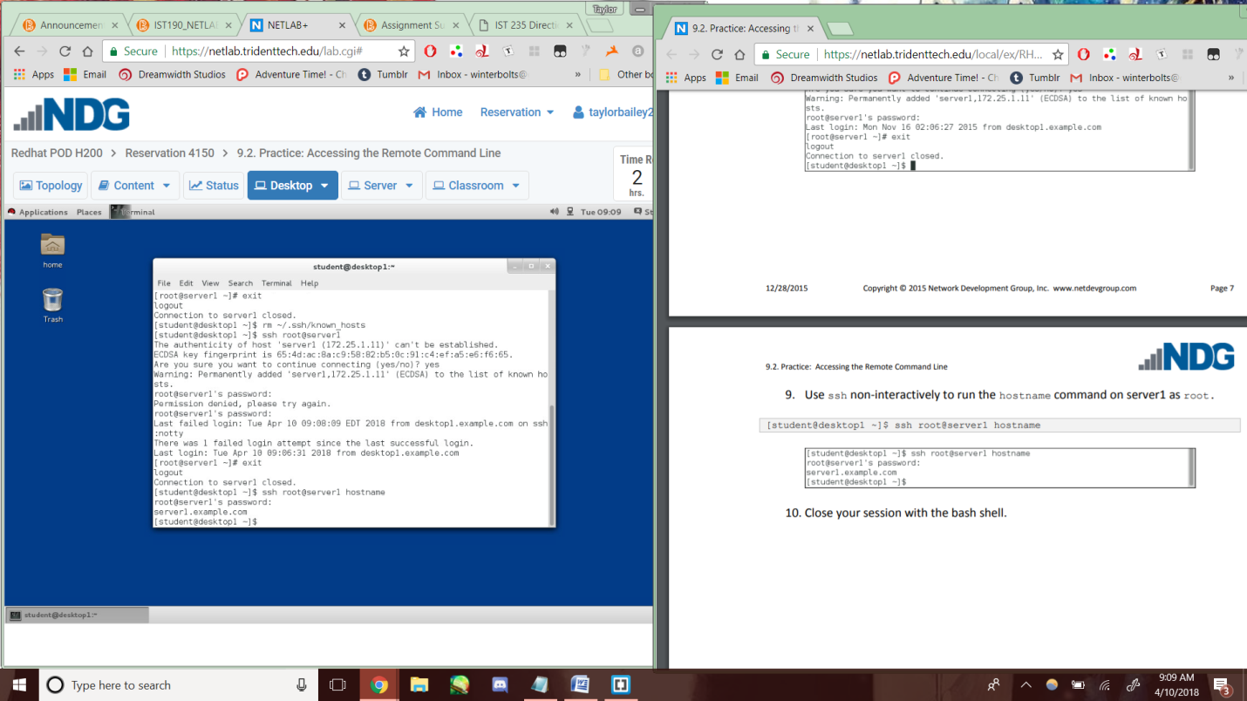

Lab5-9.4-3

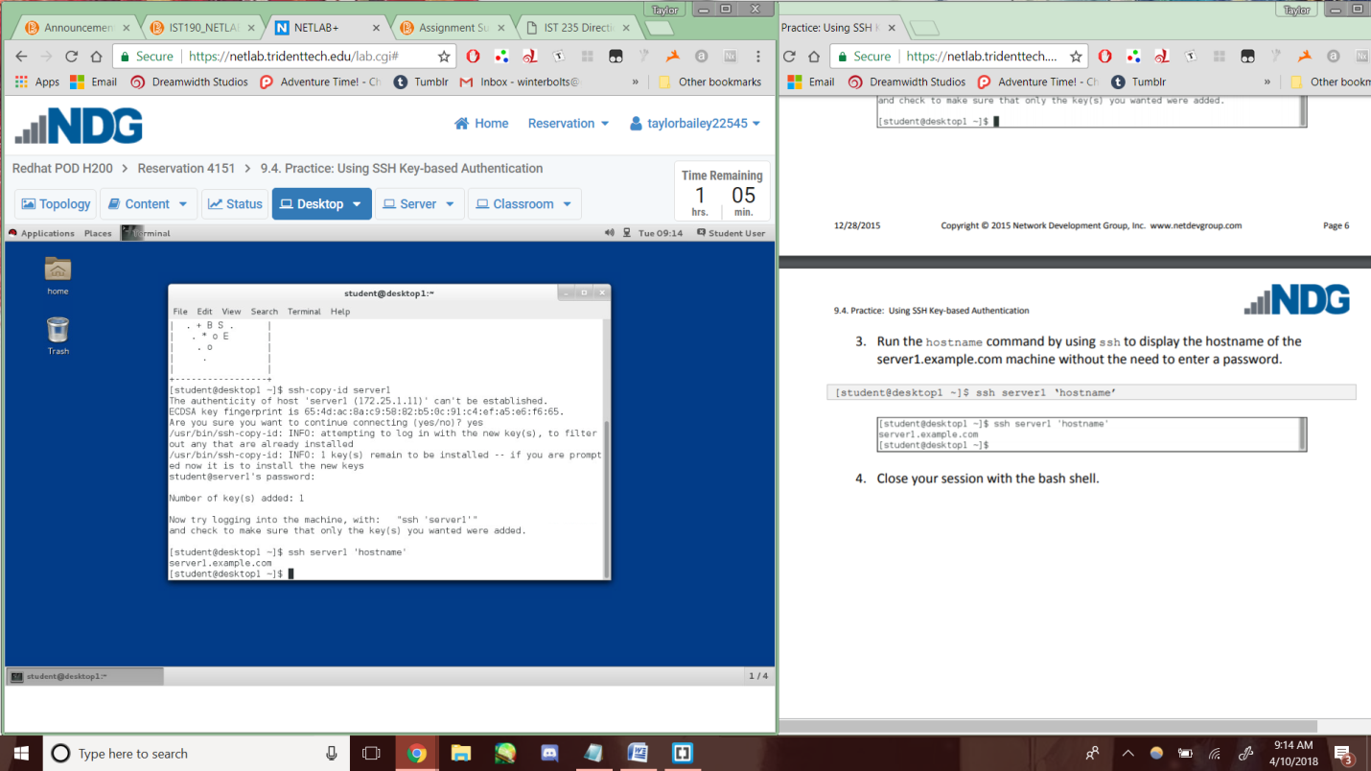

Lab5-9.6-8

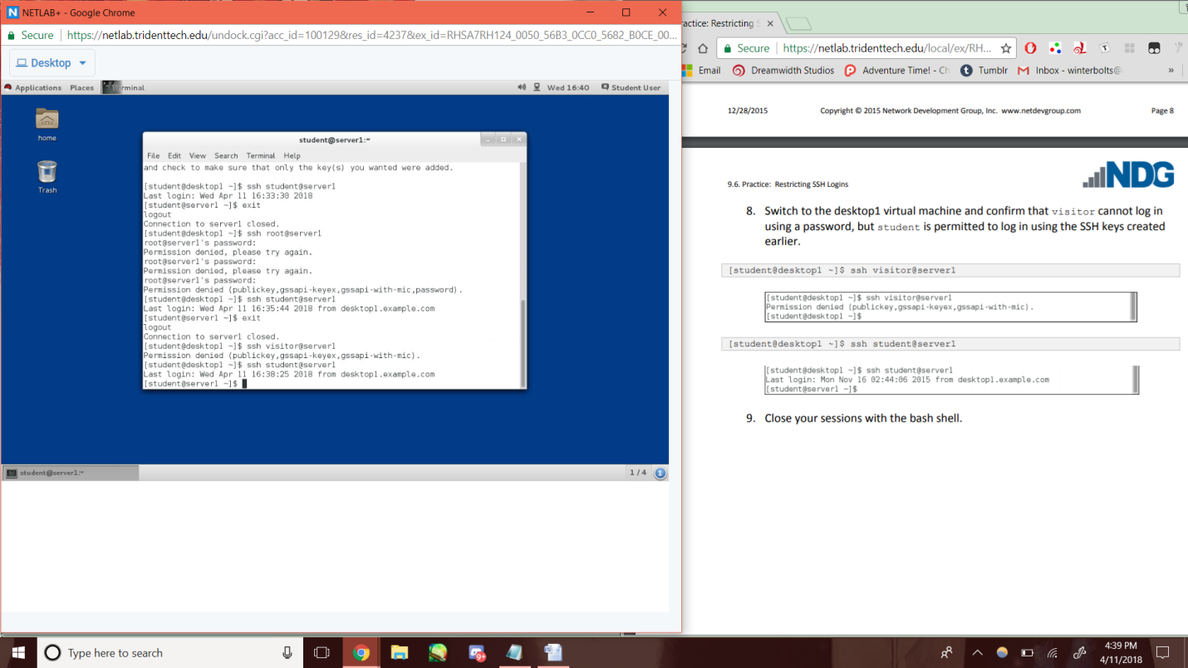

Lab5-9.7-4c

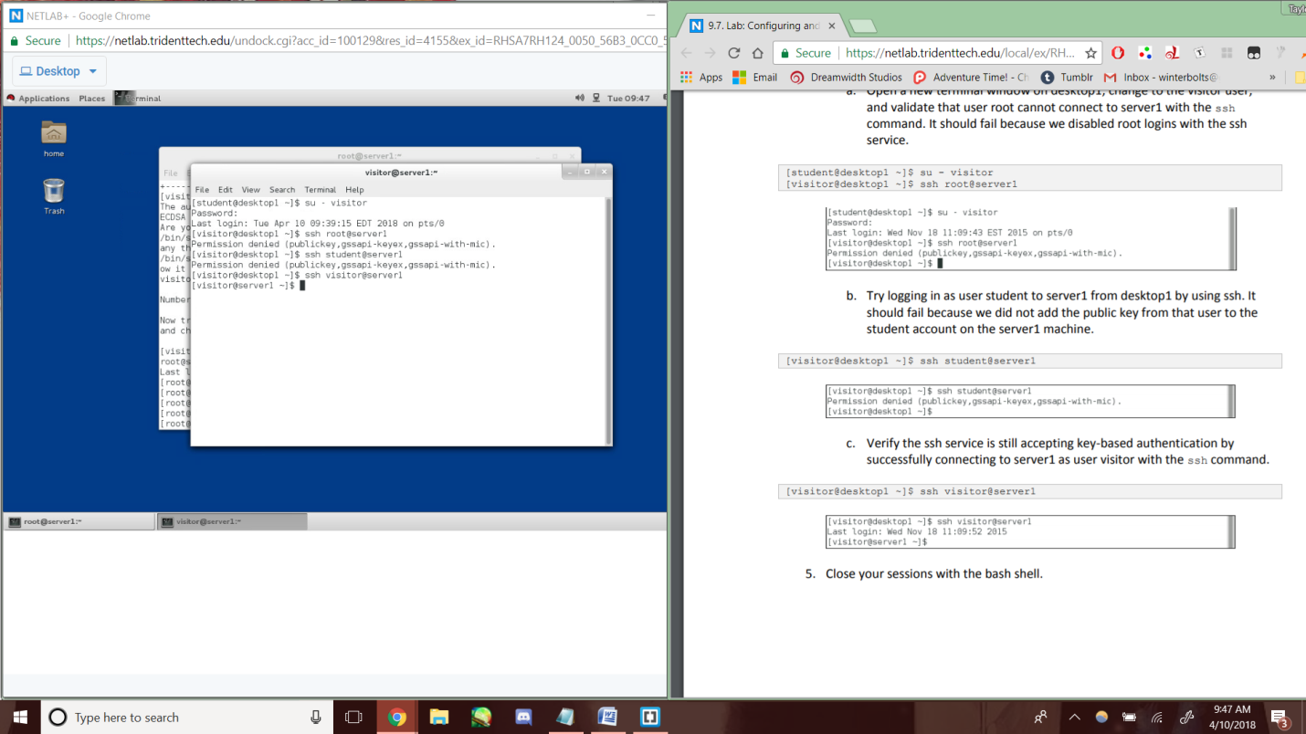

Lab5-10.4-3c

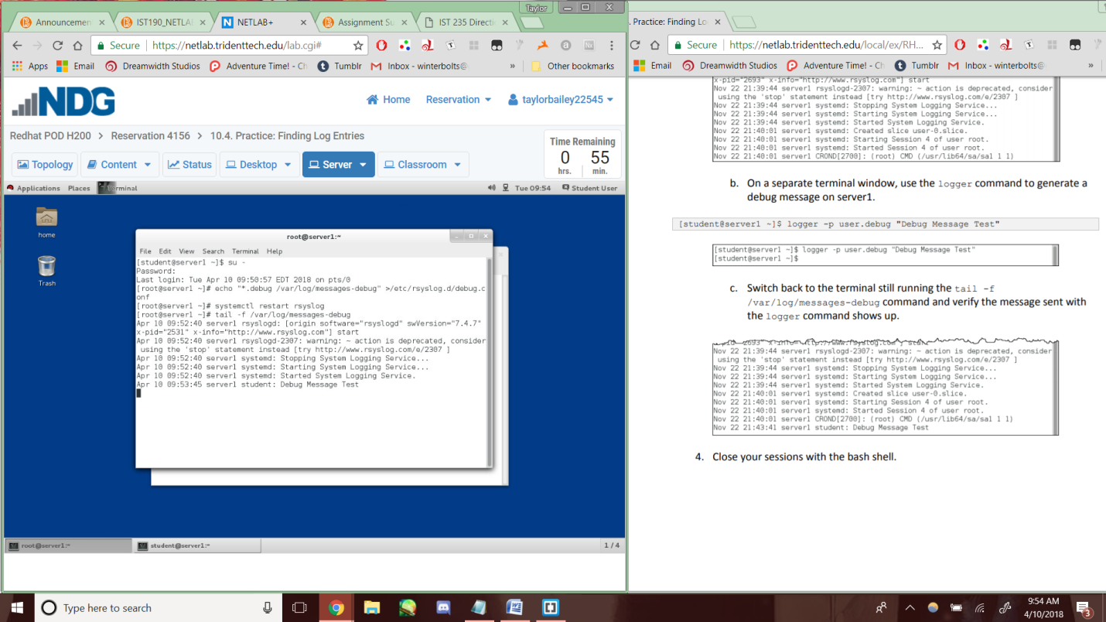

Lab5-10.6-6

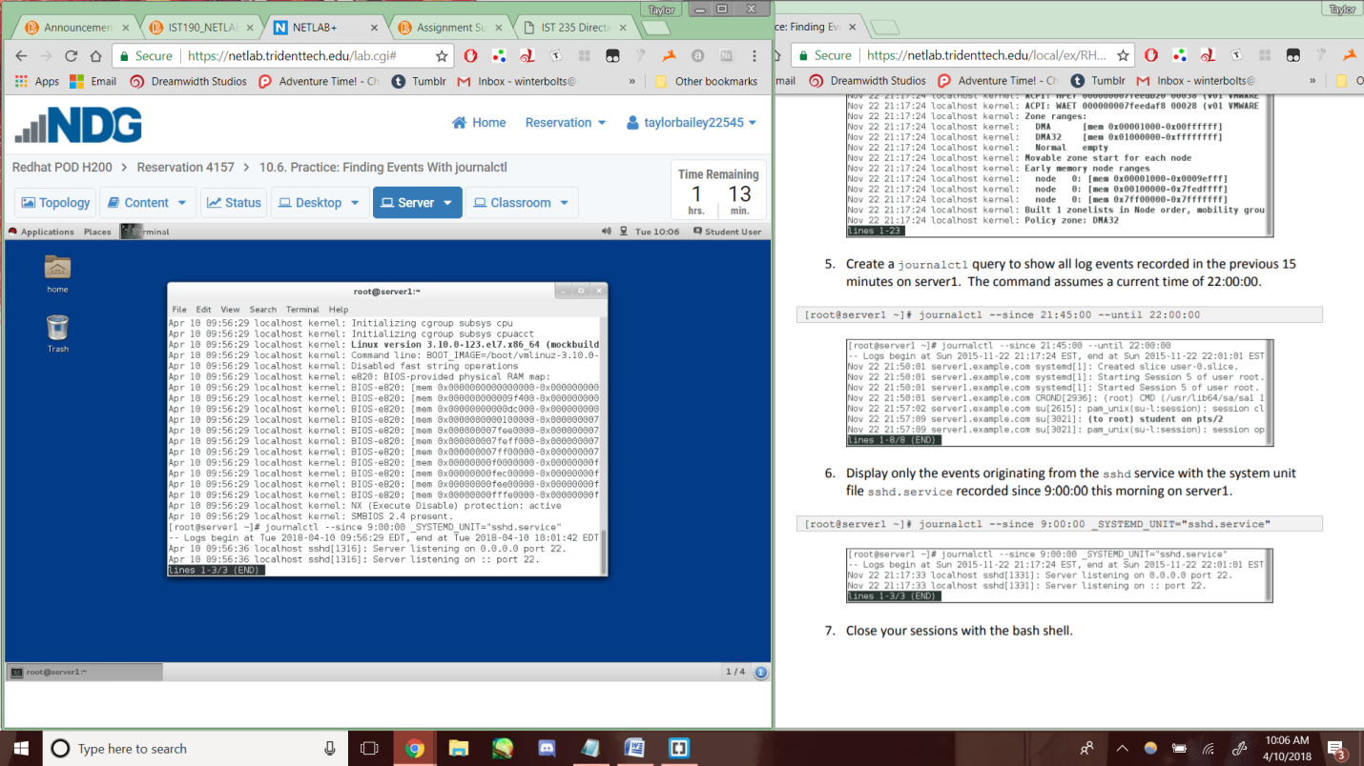

Lab5-10.8-3

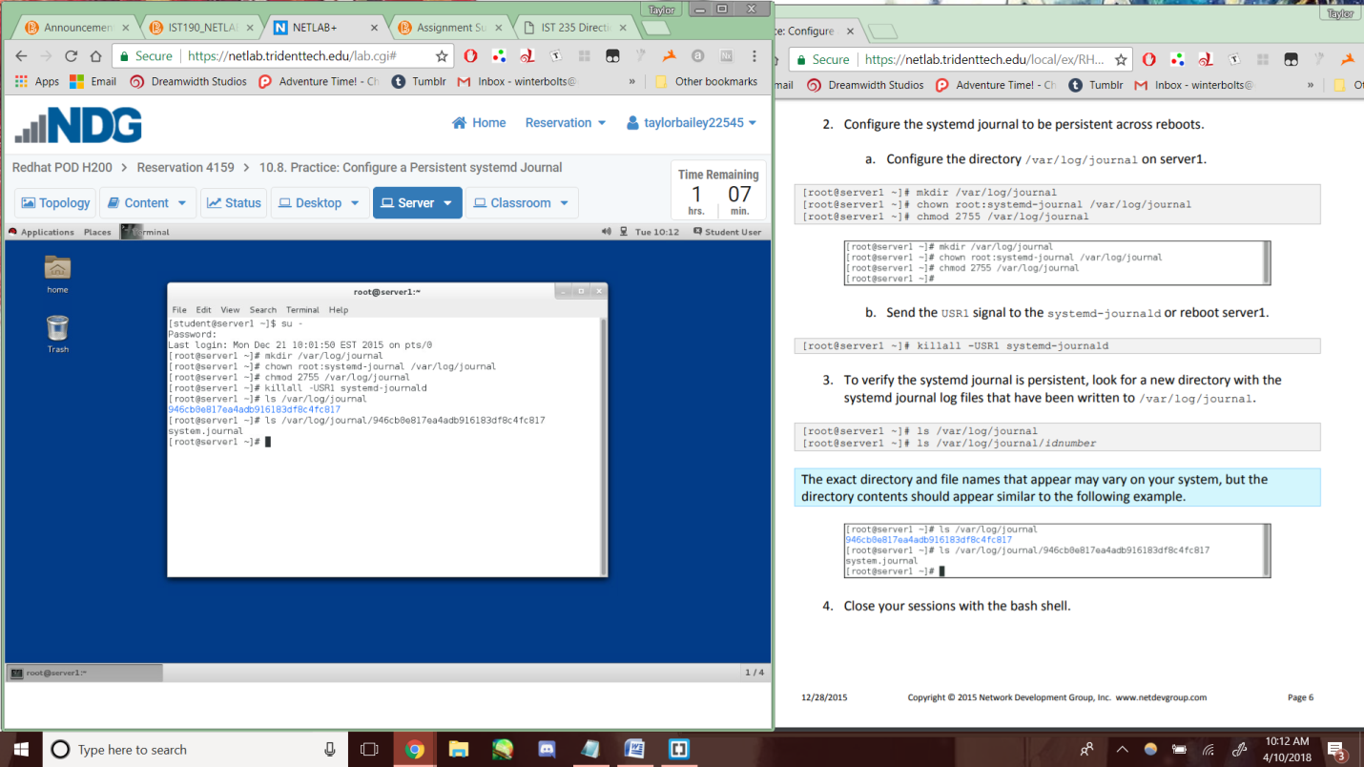

Lab5-10.11-4d

